CMPE 314

Lab5

Common Emitter Amplifier Circuit

Joshua Bastian

Benjamin Britton

**1.Purpose**

The purpose of this lab is to observe the common-emitter amplifier one of the three basic single-stage bipolar-junction transistor amplifier topologies. We will see the amplifier act as a voltage amplifier.

**2.Equipment**

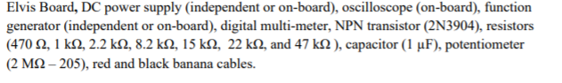

**3.Procedure**

1. Build the circuit figure 1 set Vcc = 8V, add a Capacitor 1uF

2. Measure Ibq Icq and Vceq, find the DC forward current gain. Compare the measured values of Ibq and Icq and Vceq with the calculated values.

3. Connect the sinusoidal voltage source v, with amplitude 100mV and at a frequency 10 kHz to the circuit as show. Record both down input and output voltage.

4. Increase the input sinusoidal voltage, and record down any signal distortion.

5. Use a potentiometer as a load resistor 20Mohms. Vary and measure the resistance, record down the output waveforms.

6.Plot the DC loadline and the AC loadline

7. Change R1 and R2 value to near the cutoff region Repear Steps 2-6

8. Change R1 and R2 value near the saturation region.

**3.Graphs**

4.1 Waveform

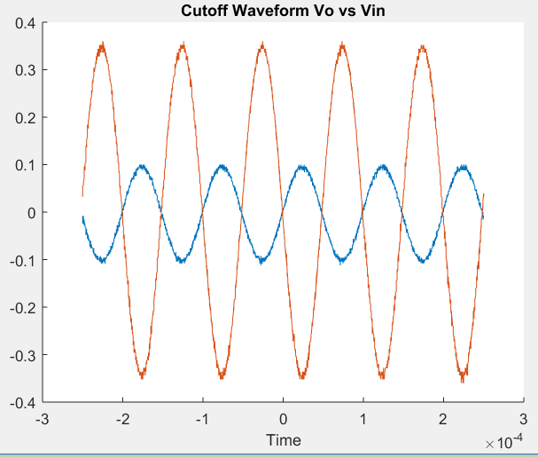

4.1 Waveform Vo vs Vin Increased input voltage

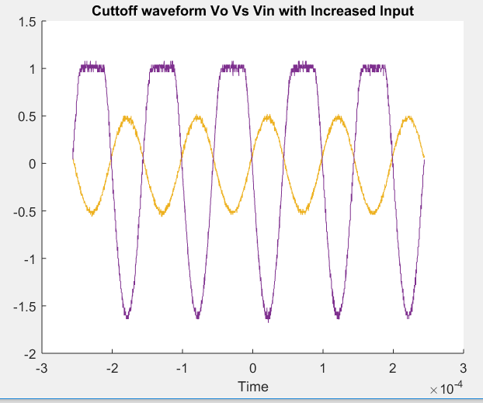

Wave form with load resistor 2Mohms Vo vs Vin

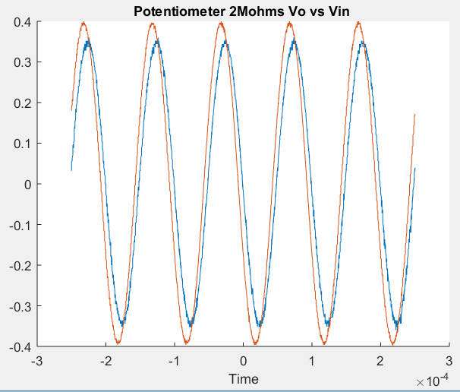

Potentiometer 0ohms

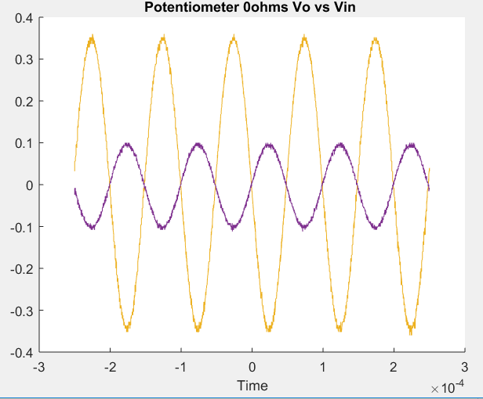

Potentiometer 1K ohms

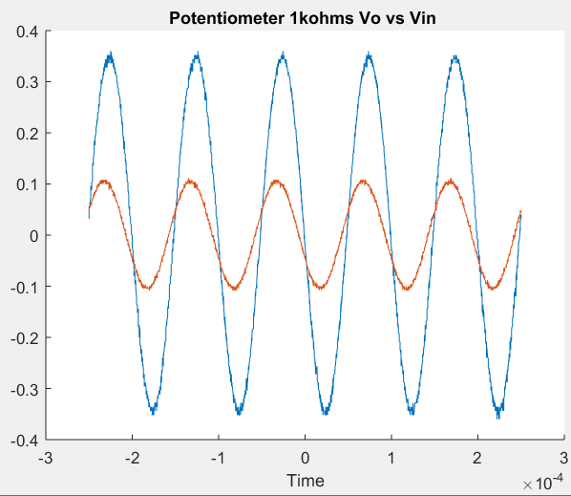

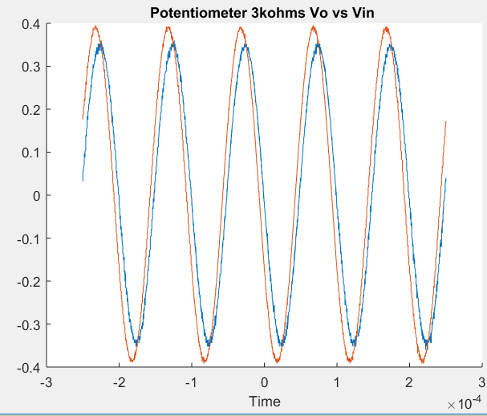Potentiometer 3kohms

Potentiometer 7.5kohms

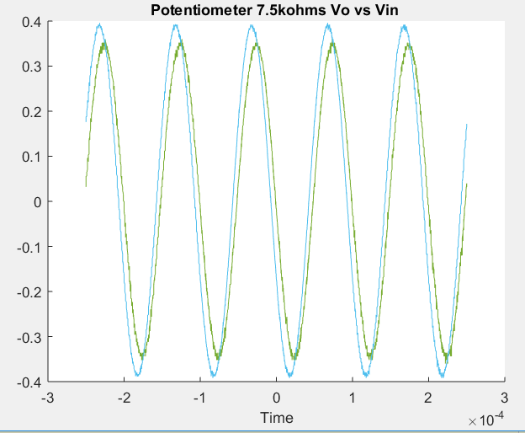

Waveform R1 = 47kohms

Saturation Waveform Increased Input Voltage

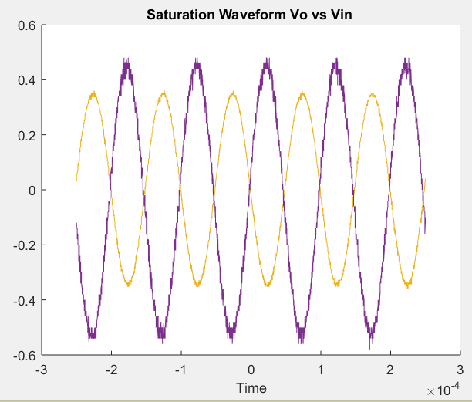

Waveform Vo vs Vin R1 = 15kohms

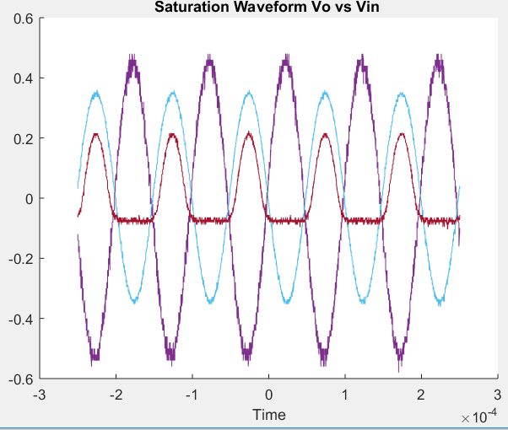

**4.Calculations**

DC Forward Current Gain

$β_{F}=I_{c}/I_{b}$ = $\frac{1.4mA}{14uA}=100$

Small Signal Voltage Gain

$A_{v}=\frac{V_{o}}{V_{s}}=\frac{874.4mV}{293.54mV}=2.9$

Maximum Symmetric Swing

$∆V_{CE}={∆i}_{c}\left(R_{c}+R_{E}\right)=\left(2.58mV-0.2mV\right)\left(2200+470\right)=6.942V$

**5.Conclusions**

In this lab we observed the characteristics of the BJT as a common emitter amplifier. With little resistance in the graph we can see the BJT act as a voltage amplifier for Vo in the emitter leg. With high resistance from the potentiometer Vo would be virtually the same as Vin. Near the saturation region the output would be reversed of the input and amplified as well. The resistors chosen show that at the amplifiers quiescent operating point, Q-point this output voltage lies half way along the transistors load line. A real-life example of this circuit could be used for an application of voltage amplification especially at low frequencies an example could be a radio frequency transceiver. The lab overall went well and was able to pull data that was usable in making the conclusions we have reached about common emitter amplifiers